Custom Physics Documentation

Eight-Ball

Connor Mills

2023

Contents

1.0 - Custom Physics Simulation Class Diagram 2

2.0 - Custom Physics Simulation Interactions 3

3.0 - Custom Physics Simulation Potential Improvements 4

3.1 - Improvement #1 4

3.2 - Improvement #2 4

4.0 - Visualised Game Using Your Custom Physics Simulation 5

5.0 - Third Party Libraries 6

6.0 - References 6

# 1.0 - Custom Physics Simulation Class Diagram

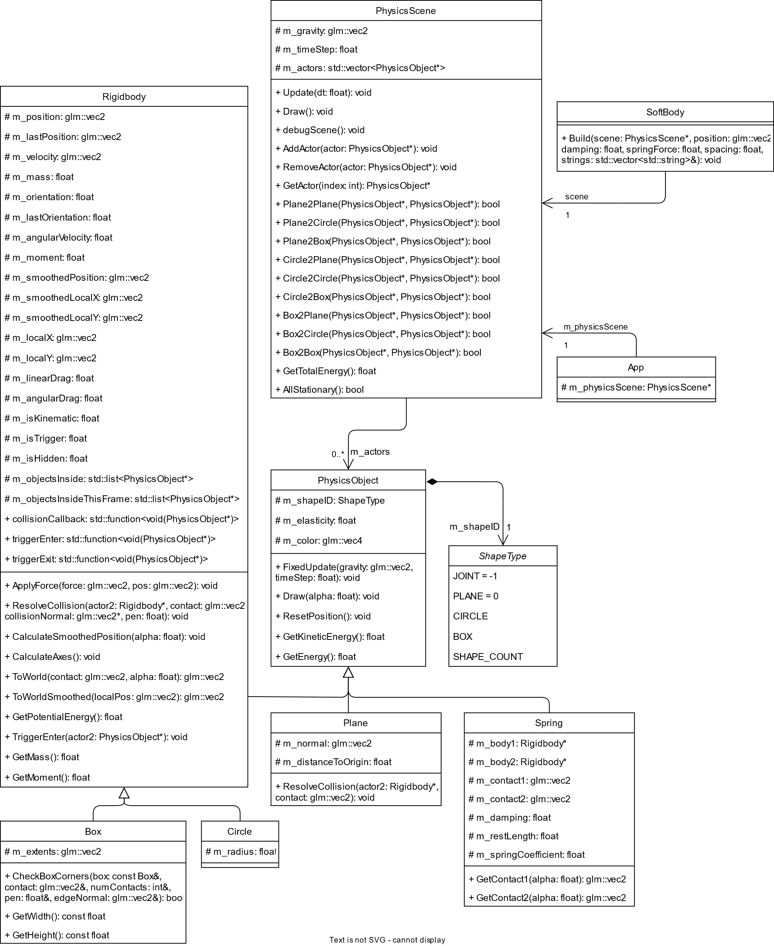

# 2.0 - Custom Physics Simulation Interactions

[Delete This] ***Define*** in your own words what your Custom Physics Simulation is demonstrating and ***outline*** how the physical bodies can interact together as dynamic and static objects. [/Delete This]

# 3.0 - Custom Physics Simulation Potential Improvements

[Delete This] The objective of this simulation is to demonstrate static and dynamic objects interaction in 2D space. ***Examine*** what improvements you could make to your simulation; this could be to:

* Support further features.
* provide a more accuracy.
* Make it more precise.
* Improve the quality.

(This refers to custom physics simulation library you are creating, not directly the game you have created. These are not always mutually exclusive however.) [/Delete This]

## 3.1 - Improvement #1

Friction and force applied by friction

## 3.2 - Improvement #2

Quadtrees for collision detection

# 4.0 - Visualised Game Using Your Custom Physics Simulation

[Delete This] ***Define*** what your visualisation (chosen game) is and then ***explain*** how you created it and how it works. (Include Image/s). [/Delete This]

# 5.0 - Third Party Libraries

The only third-party non-physics library that was used was Bootstrap. Bootstrap was the library provided by AIE, I used for rendering and visualising all the physics objects in the eight-ball game. I also used it for getting the input information from the mouse and keyboard. I did not use any other third-party libraries as they were not needed.

# 6.0 - References

[Delete This] List of references and research material used to influence the creation of your custom physics simulation and where you researched to improve the quality of the system.

Use the Harvard Citation Method to cite books and websites used. Here is a link to a good citing website if you are unsure how to do so <https://www.citethisforme.com/citation-generator/harvard> [/Delete This]

Lambert, S. (2012) *Quick tip: Use quadtrees to detect likely collisions in 2d Space*, *Game Development Envato Tuts+*. Envato Tuts. Available at: https://gamedevelopment.tutsplus.com/tutorials/quick-tip-use-quadtrees-to-detect-likely-collisions-in-2d-space--gamedev-374 (Accessed: February 20, 2023).

Kang, J. (2014) *An interactive explanation of quadtrees*, *An interactive explanation of Quadtrees.* Available at: https://jimkang.com/quadtreevis/ (Accessed: February 20, 2023).